Date: 15 March 2024

Name: PADAM SINGH

Trade: IBM-ADIT

Subject: Elective Module – 3 (Web Development using JS Framework)

Roll no: ADIT-97

Registration no: ADIT22AP00545

**Aim:** Create an Express app with 3 routes - /about, /home and /contact. Display separate html contents when the user accesses each route.

**Solution**

Requirement/Tools:

* Operating System – Windows 10/11 or Linux
* Command Prompt/Power Shell
* Internet Connectivity, Browser (Chrome or Edge)
* Text Editor – Notepad / IDE – Visual Studio Code/Any IDE
* NodeJS, Angular CLI

**Step/Code:**

1. We need to create a folder. I have created a folder whose name is Elective module 3.
2. Right-click on it and open it in the integrated Terminal.

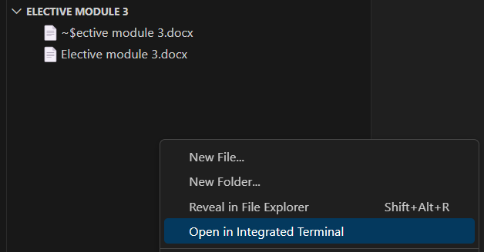

1. We need some packages for that run these commands.

npm init -y (This command creates a package.json file).

npm i express nodemon

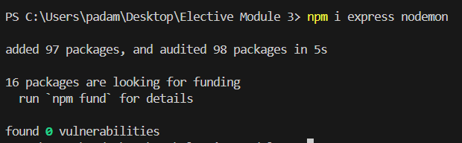

1. If you want to check whether packages are installed or not then open the package.json file and you can see your all-installed packages.

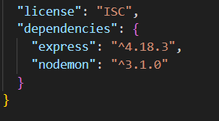

1. Create a file I give the name index.js and add this code inside of the index.js

|  |
| --- |
| // import the express module  const express = require('express')  const app = express();  // static files  app.use(express.static(__dirname + '/public'));  //route for home page  app.get('/home', (req, res) => {  res.sendFile(__dirname + '/index.html');  })  //route for about page  app.get('/about', (req,res)=>{  res.sendFile(__dirname + '/about.html');  })  //route for contact page  app.get('/contact', (req,res)=>{  // res.send('Welcome to the Contact page');  res.sendFile(__dirname + '/contact.html');  })  //start the server on port 3000  app.listen(3000);  console.log('listening on port 3000: http://localhost:3000/'); |

1. Now create index.html, about.html and contact.html and add this code inside the file.

**index.html**

|  |
| --- |
| <!doctype html>  <html lang="en">  <head>  <title>Home page</title>  <!-- Required meta tags -->  <meta charset="utf-8" />  <meta name="viewport" content="width=device-width, initial-scale=1, shrink-to-fit=no" />  <!-- Bootstrap CSS v5.2.1 -->  <link href="https://cdn.jsdelivr.net/npm/bootstrap@5.3.2/dist/css/bootstrap.min.css" rel="stylesheet"  integrity="sha384-T3c6CoIi6uLrA9TneNEoa7RxnatzjcDSCmG1MXxSR1GAsXEV/Dwwykc2MPK8M2HN" crossorigin="anonymous" />  <link rel="stylesheet" href="css/style.css">  </head>  <body>  <h1>Home Page</h1>  <p>Lorem ipsum, dolor sit amet consectetur adipisicing elit. Maxime voluptates illo hic vero cupiditate animi  quaerat dolore, labore at voluptatibus corrupti eum modi nulla eos fugiat dolores reiciendis error ipsam quis  maiores cum magni. Vitae omnis saepe reiciendis ab obcaecati, quod pariatur eos, iure corporis odit amet  delectus quibusdam, magni quasi esse eligendi vero totam culpa dolore molestias suscipit eum? Dolore natus  ducimus itaque doloremque voluptas cum. Blanditiis consequuntur maiores architecto, earum, iure mollitia tempore  quo facilis dolorem cupiditate voluptatem commodi vero officia reiciendis doloremque dolorum laudantium! Aliquam  eum assumenda sit accusantium porro sint rem quia dolores, libero, nulla magnam?</p>    </body>  </html> |

**about.html**

|  |
| --- |
| <!doctype html>  <html lang="en">  <head>  <title>About</title>  <!-- Required meta tags -->  <meta charset="utf-8" />  <meta  name="viewport"  content="width=device-width, initial-scale=1, shrink-to-fit=no"  />  <!-- Bootstrap CSS v5.2.1 -->  <link  href="https://cdn.jsdelivr.net/npm/bootstrap@5.3.2/dist/css/bootstrap.min.css"  rel="stylesheet"  integrity="sha384-T3c6CoIi6uLrA9TneNEoa7RxnatzjcDSCmG1MXxSR1GAsXEV/Dwwykc2MPK8M2HN"  crossorigin="anonymous"  />  <link rel="stylesheet" href="css/style.css">  </head>  <body>  <h1>About Page</h1>  <p>Lorem ipsum, dolor sit amet consectetur adipisicing elit. Maxime voluptates illo hic vero cupiditate animi  quaerat dolore, labore at voluptatibus corrupti eum modi nulla eos fugiat dolores reiciendis error ipsam quis  maiores cum magni. Vitae omnis saepe reiciendis ab obcaecati, quod pariatur eos, iure corporis odit amet  delectus quibusdam, magni quasi esse eligendi vero totam culpa dolore molestias suscipit eum? Dolore natus  ducimus itaque doloremque voluptas cum. Blanditiis consequuntur maiores architecto, earum, iure mollitia tempore  quo facilis dolorem cupiditate voluptatem commodi vero officia reiciendis doloremque dolorum laudantium! Aliquam  eum assumenda sit accusantium porro sint rem quia dolores, libero, nulla magnam?</p>    </body>  </html> |

**contact.html**

|  |
| --- |
| <!doctype html>  <html lang="en">  <head>  <title>Contact</title>  <!-- Required meta tags -->  <meta charset="utf-8" />  <meta  name="viewport"  content="width=device-width, initial-scale=1, shrink-to-fit=no"  />  <!-- Bootstrap CSS v5.2.1 -->  <link  href="https://cdn.jsdelivr.net/npm/bootstrap@5.3.2/dist/css/bootstrap.min.css"  rel="stylesheet"  integrity="sha384-T3c6CoIi6uLrA9TneNEoa7RxnatzjcDSCmG1MXxSR1GAsXEV/Dwwykc2MPK8M2HN"  crossorigin="anonymous"  />  <link rel="stylesheet" href="css/style.css">  </head>  <body>  <h1>Contact Page</h1>  <form action="">  <div class="mb-3">  Name:  <input type="name" class="form-control" name="" id="">  <label for="" class="form-label">Email</label>  <input  type="email"  class="form-control"  name=""  id=""  aria-describedby="emailHelpId"  placeholder="abc@mail.com"  />  <small id="emailHelpId" class="form-text text-muted"  >Help text</small  >  </div>  <input type="button" value="Submit" class="btn btn-primary" />    </form>  <!-- Bootstrap JavaScript Libraries -->    </body>  </html> |

1. Now what we need to do is create a public folder and inside of this folder create a folder css. Now create a style.css file.

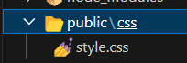

1. Add this code inside the style.css file

|  |
| --- |
| body{  margin-top: 5%;  }  h1{  color: green;  text-align: center;  font-size: 50px;  font-family: 'Gill Sans', 'Gill Sans MT', Calibri, 'Trebuchet MS', sans-serif;  }  p{  padding: 10%;  }  form{  padding: 10%;  } |

1. Now link the css to all .html pages add this link to the all-html file.

|  |
| --- |
| <link rel="stylesheet" href="css/style.css"> |

1. Go to the terminal and run this command. Then click on the **http://localhost:3000/.**

Set-ExecutionPolicy -Scope Process -ExecutionPolicy Bypass

nodemon index.js

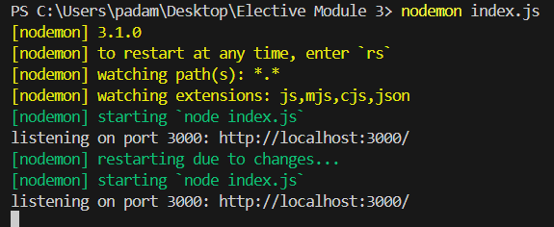

Output:

**/home**



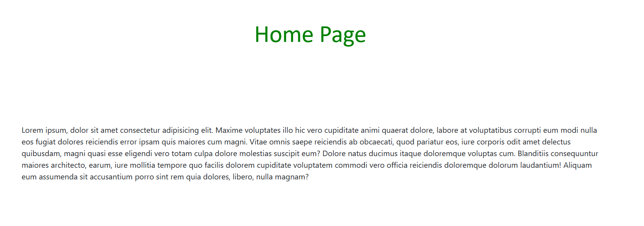

**/about**

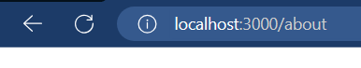

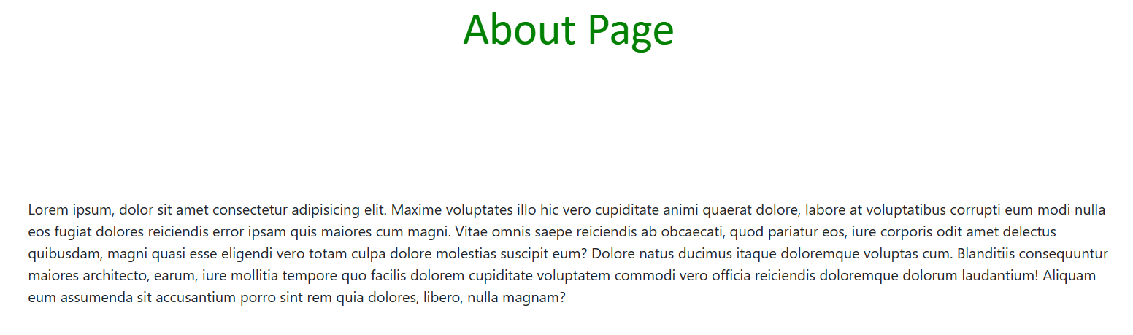

**/contact**

